IT5010: Assignment #1

Practical Project – Case Study

Report

Student Name: | Basharat Habib
Student ID: | 20267244
Due Date: | 28/08/2026

1

Contents

1. Executive Summary 2
2. Network Diagram 3
3. Quotation 3
4. (D) Communication Channel Security 4
5. (E). Support Call Prioritisation 5
7. References 5

Executive Summary

In this case study, I designed a secure, scalable, two‑site network for Spring Computers, which connected Wellington to a new Auckland Help Desk office, while supporting printers, hardware, help‑desk software, call‑prioritisation tools, all other required accessories and infrastructure, and staying under a $20,000 budget. All components were chosen based on reliability, cost efficiency, performance, and suitability for a small-to-medium sized IT business with a possibility of adding more sites in the future.
My proposed setup uses TP-Link Omada routers, switches, and wireless access points to deliver an integrated, centrally controlled network across both Wellington and Auckland sites. A site-to-site IPSec VPN secured with AES-256 encryption and IKEv2 ensures confidential and non-external communication between both network sites. Additionally, I have added security layers, consisting of Microsoft Defender for Cloud and built-in firewall feature. These will protect the devices from viruses, malware, unauthorised access, and network dangers.
To support the functioning of daily operations, this project also includes cloud-based Windows Server Virtual Machines (VMs) hosted on Microsoft Azure. This will help to eliminate hardware maintenance while still providing good computer resources. The computers selected are the Lenovo all-in-one PCs, as they have many built in features required for smooth operations. In addition to this, they also include a mouse, a keyboard, and a built-in webcam. Other peripheral devices used are the HP multifunction printers (various uses as seen in the table ahead), UPS devices (for power backups), and Cat6 cables ensure reliable performance and business stability.
For call sorting and prioritisation, a structured P1–P4 call prioritisation model is used with the help of Spiceworks Help Desk. This system is very efficient and very cost effective, and it categorises issues by severity, assigns them to correct IT technicians, and applies correct SLA response times.
Overall, the proposal in this project provides secure, durable, and professionally managed network systems. It supports the current business needs while allowing easy expansion as Spring Computers adds more networking sites. The combination of cloud services, modern hardware, and a well-organized help-desk workflow ensure high availability, strong security, and professional IT operations.

Network Diagram
(Enter a network Diagram here and give an explanation. You can use www.draw.io to draw the network
diagram online. Make sure all components are labelled.)

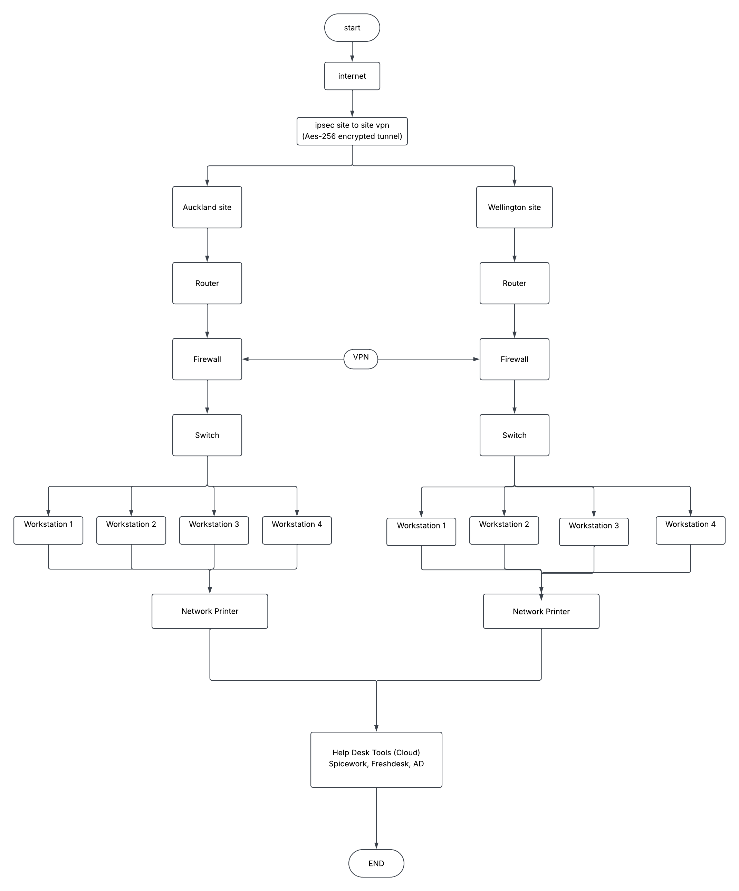

Quotation
(Fill in the table to answer Tasks A, C and E)

Items | Cost | C. Rationale and Justification for each component  (Provide brief justification about why you chose this specific item.) | Reference  APA (7th ed.) format. E.g., (Rasmussen, 2021, para. 2)
Hardware software components  Router:  TP-Link Omada ER707-M2 2.5G Multi-WAN VPN Gateway  (2x)  1 router per worksite | $298.00 x2  $596 | Router with integrated firewall  Ethernet Ports Per Unit 6  Excellent for site to site VPN  It covers routing + firewall + VPN + multi-WAN + network security in one device | (PB Tech, n.d.-a)
Switch:  TP-Link Omada ES208GP 8-Port Gigabit Easy Managed Switch (64W) - 1GbE PoE+ x8  (2x)  1 switch per worksite | $116.85 x 2  $233.7 | Contains 8 ports which can easily connect to the work computers and the printer.  It provides port isolation, loop prevention, and doesn’t require separate power adapters. | (PB Tech, n.d.-b)
Wireless access Point:  TP-Link EAP610 Indoor Wi-Fi 6 AX1800 Wireless Dual Band Ceiling AP  (2x)  1 WAP per worksite | $199.00 x 2  $398 | It can help create separate wireless networks like guest wifi or staff wifi.  Provides wireless security. | (Smiths City, n.d.)
Servers:  Microsoft Azure Windows Server VM – New Zealand North  For 8 CPUs | $330.9078/month  $3970.893/year | Is compatible with windows 11.  Azure virtual setup is good for a moderate sized network.  Can support 8 CPUs.  No hardware maintenance.  Easy RAM and storage increase.  Can have a backup.  It runs on the 3rd Generation Intel® Xeon® Platinum 8370C (Ice Lake) processor. | (Microsoft, n.d.-a)
Spiceworks | $5 per seat per month  5x8 = $40/month  40x12 = $480/month | Monitors networks at both sites.  Can help identify specific problems in a system.  Helps sort and prioritise tickets.  Can identify any unauthorised devices on the network. | (Spiceworks, n.d.)
Lenovo A100 23.8" FHD All-in-One (8x)  4 PCs in Wellington  4 PCs in Auckland | $944.44 x 8  $7555.52 | Intel® N100  256GB SSD M.2 PCIe® NVMe®  23.8" FHD (1920x1080)  Intel N100 - 8GB RAM - 256GB SSD - Win 11 Home - AX WiFi 6 + BT5.2 - Webcam - HDMI1.4b out - RJ45  Includes keyboard and mouse in the same price | (PB Tech, n.d.-c)
Network printers (printer)  HP LaserJet Pro 4301FDW MFP Color Laser A4 Wireless Printer (2x)  1 Printer per worksite | $695.00 x 2  $1390 | Scan / Print / Copy / Fax  Wireless  Laser printing both colour and black and white | (PB Tech, n.d.-d)
Infrastructure  Unlimited Power Supply (UPS) device:  APC Easy UPS SMV Tower  1 per worksite | $731.23 x2  $1462.46 | Line-Interactive, Pure Sine Wave Output, 6 x C13 Outlets, Smartslot.  In case of power outage or fluctuation, it provides backup power to essential devices like router, switch, server.  2 Years Warranty | (PB Tech, n.d.-e)
Cruxtec Cat6 Ethernet Cable - 5m – Blue  (12x)  6 cables per work site | $13.98 per cable  $167.76 | 6 cables per site (4 computers, 1 printer, 1 router)  5 meter long  Gigabit ethernet  Gold-plated RJ45 connectors make it highly conductive and durable | (PB Tech, n.d.-f)
Accessories  Headsets  Logitech H151 Wired Over-Ear Headset - Black (981-000587)  (8x)  4 headsets per worksite | $68.78 x 8  $550.24 | Windows, macOS, ChromeOS, Android, iOS with 3.5 mm Jack  Wired  Bidirectional communication | (Harvey Norman, n.d.)
Security protocols:  Microsoft Defender for cloud | $25/month  $300/year | Helps in malware and virus detection.  Controls connections on the PCs.  Let’s approve applications of work but blocks unauthorised network connections. | (Microsoft, n.d.-b)

(D) Communication Channel Security
(Explain how you will secure the communication channel between the two sites.)
The communication channel between the Wellington and Auckland sites will be secured using a site-to-site secure encrypted communication channel, in other words, the site-to-site IPSec VPN between the two sites. Our routers present at both sites have built in firewalls which will develop the encrypted VPN tunnel.
The VPN will use IKEv2 (Internet Key Exchange version 2) to carefully develop a connection between the two site specific firewalls using AES-256 encryption to protect the data travelling through the tunnel between two sites.
The firewall will only allow authorised devices to connect to the network. Also, the Multifactor Authentication (MFA) will allow access only to devices after a multistep verification is done.

(E). Support Call Prioritisation
(Explain how you will prioritise the calls. You can list the rules that you have defined and practiced using Spiceworks.)

Call prioritisation will be done based on the severity of the issue related to it. There can be two main sorts of problems. One would be a fault in the system, and the second one would be unassigned or accumulated tickets.
First and foremost, the system faults will be dealt with and if I can resolve those issues on my own then that would be done. If these problems are not related to me or if they are quite a few in number, then I would ask for the help of my co-workers. If the issue/issues can not be resolved by me, I would send them onwards to the specific support persons.

When the system issues are resolved, I will look at resolving the tickets (undocumented calls) accumulated. For this issue I will look at using Spiceworks. It will help me prioritise the calls based on their impact and severity. Call prioritisation will help us resolve all issues ranging from critical to minor between both network sites i.e., Wellington and Auckland.

We will prioritise the support calls using a P1-P4 priority system, divided into 4 levels:
P1 will be used for Critical issues such as a problem affecting network failure.
P2 will be used for High issues such as something that affects many users of the network together.
P3 will be used for medium issues such as a single or individual user problem.
P4 will be used for Low issues like minor problems that don’t require urgent help.

Each priority level will have a set response time with P1 having the fastest and P4 having the lowest response times.

In addition to this, the tickets will also need to be assigned to the correct IT technician based on its type e.g. Hardware and Software. (Schoen, 2013)

- Summary
(Reflect on your learning and the challenges of designing a network solution)
Total Budget = $20,000
Budget used in this project = $17,103
Designing a network solution for Spring computers network sites in Wellington and Auckland has helped me understand what designing, planning, and implementing is required for a project like this. I have become aware of what real world constraints I would have to face to achieve a design like this. I would have to keep in mind the budget, time, efficiency, security, and effective communication challenges.
I have gained knowledge regarding what components are required to build a new network site and how its connection can be established with another site. I have also learned what kind of software, hardware, Computing components, and extras would I require to achieve a working network site within a budget of $20,000 and some to spare. I have gained a better understanding of what all different components of a network site do, from a router to a server and even down to the ethernet cables.
I learned about the site-to-site VPN connection and security. How the codes are sent and how information is transferred between the two networks. I understood clearly what the VPN security is and how it differs from endpoint security (as well as different malware deterrent tools like the Microsoft defender). I learned different types of servers and how a cloud server works as well as its advantages and disadvantages compared to a hardware server.

The main challenges I faced when designing this project would be first, choosing the right components (hardware, software, etc) within the provided budget. Second, it would be designing and developing a safe secure communication network channel. Third, I will say would be the balance of practical and expandible device use. The use of chosen devices will allow us to easily expand to new sites in the future. Last, I believe will be implementation of efficient workflow in real world environments. For call priority and the right response, I believe spice works has helped solved many issues. It’s fast sorting, prioritizing, and responding helps clear the incoming tickets fast.
All these challenges have helped me look at the IT networking setup from a real-life perspective and made me realise what challenges and problems I could face and how they can be overcome.

References:

Harvey Norman. (n.d.). Logitech H151 wired headset black. https://www.harveynorman.co.nz/computers/computer-accessories-en/webcams-microphones-headsets/logitech-h151-wired-headset-black.html

Microsoft. (n.d.-a). Windows Virtual Machines pricing. https://azure.microsoft.com/en-us/pricing/details/virtual-machines/windows/

Microsoft. (n.d.-b). Microsoft Defender for Cloud pricing. Microsoft Azure. https://azure.microsoft.com/en-us/pricing/details/defender-for-cloud/

PB Tech. (n.d.-a). TP-Link Omada ER707-M2 2.5G multi-WAN VPN gateway router. https://www.pbtech.co.nz/product/NETTPL25707/TP-Link-Omada-ER707-M2-25G-Multi-WAN-VPN-Gateway-R

PB Tech. (n.d.-b). TP-Link Omada ES208GP 8-port Gigabit Easy Managed switch. https://www.pbtech.co.nz/product/SWHTPL2082/TP-Link-Omada-ES208GP-8-Port-Gigabit-Easy-Managed

PB Tech. (n.d.-c). Lenovo A100 23.8" FHD all-in-one Intel N100, 8GB RAM. https://www.pbtech.co.nz/product/WKALEN34710/Lenovo-A100-238-FHD-All-in-One-Intel-N100---8GB-RA

PB Tech. (n.d.-d). HP LaserJet Pro 4301fdw MFP color laser A4 wireless printer. https://www.pbtech.co.nz/product/PTRHPL5738151/HP-LaserJet-Pro-4301FDW-MFP-Color-Laser-A4-Wireles

PB Tech. (n.d.-e). APC Easy UPS SMV Tower 1500VA/1050W LCD line-interactive UPS. https://www.pbtech.co.nz/product/UPSAPC001500/APC-Easy-UPS-SMV-Tower-1500VA--1050W-LCD-Line-Inte

PB Tech. (n.d.-f). Cruxtec Cat6 Ethernet cable—5m—blue. https://www.pbtech.co.nz/product/CABCXT840500/Cruxtec-Cat6-Ethernet-Cable---5m---Blue

Schoen, D. (2013). Getting started with Spiceworks: Install, configure, and get real results from Spiceworks in just a couple of hours. Packt Publishing.

Smiths City. (n.d.). TP-Link EAP610 indoor Wi-Fi 6 AX1800 wireless dual-band ceiling access point. https://smithscity.co.nz/products/tp-link-eap610-indoor-wi-fi-6-ax1800-wireless-dual-band-ceiling-ap

Spiceworks. (n.d.). Free cloud help desk software pricing. https://www.spiceworks.com/free-cloud-help-desk-software/pricing/

